**MWH Ecosystem Sentinel – Market Squid**

Ecosystem sentinels are defined as conspicuous species that are highly responsive -sensitive- to ecosystem variability and/or change in a timely, measurable, and interpretable manner (Hazen et al. 2019). Market squid range (Okutani and McGowan 1969, Wing and Mercer 1990), spawning patterns (Street 1983, Ziedberg et al. 2011, Navarro et al. 2018, Cheng et al. 2020, Van Noord et al. 2020), age (Jackson and Domeier 2003), and composition in the diet of predators (Lowry and Carretta 1999) and fishery harvest (Aguilar et al. 2015) are parameters that allow researchers to interpret ecosystem variability, as has been already been clearly demonstrated for the ENSO (Vojkovich et al. 1998, Zeidberg et al. 2002, Jackson and Domeier 2003, Koslow and Allen 2011, Perretti et al. 2016, Van Noord et al. 2017). Emerging data supports that temporary range extensions waters that historically extended into the Gulf of Alaska for several weeks during a strong El Niño and only to limited geographic areas of southeast Alaska, now, are becoming more prolonged with a strong El Niño combined with MWH interactions where market squid extend into the Gulf of Alaska for *several years* with broad geographic distribution throughout southeast Alaska as well as limited geographic areas of southcentral Alaska (this paper).

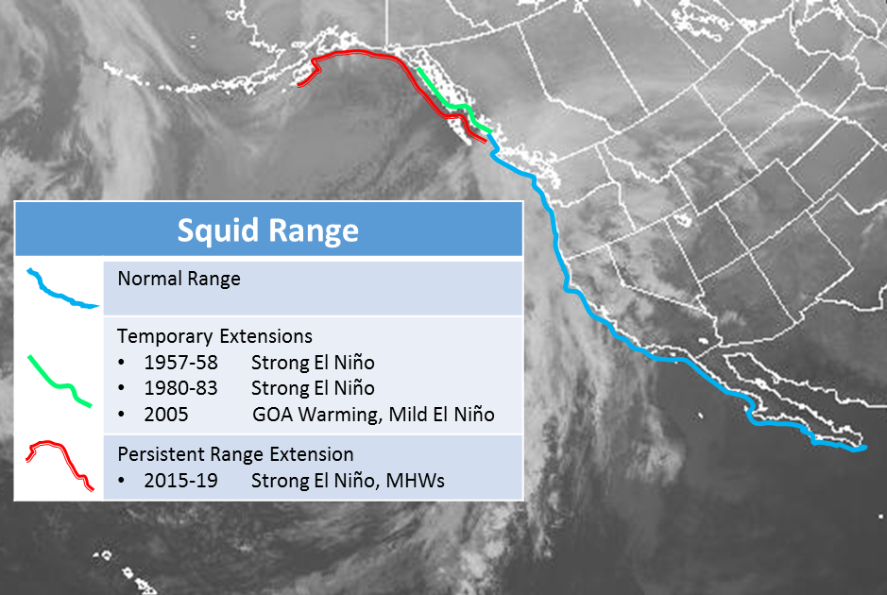

Figure [ ]. Squid range and extensions with positive-phase ENSO and MWH. Blue = normal range, Green= temporary extensions, Red = persistent range extension

Table [ ]. Latitudinal Variation

|  |  |  |
| --- | --- | --- |
| Life Stage | Southern Clines (22°-39°) | Northern Clines (40°-58°) |
| Embryo | Rapid hatching | Expanded range |
| Paralarva  Juvenile  Adult | Higher metabolism/  Less energy for growth  Small  Small young adults | Access to large food sources  Large  Large old squid |
| *Spawning Adults* | Habitat degradation  Monthly cohorts/cycles | Habitat expansion  ~Yearly cycles |

Market squid track oceanographic conditions well through their life history and their migration patterns. In southern clines, they can compress their spawning to the shallows (< 40 m) during Ninas when lower-shelf oxygen and pH levels drop (respectively, <160 μmol, <7.8) on mid and lower parts of the shelf and expand during Ninos when oxygen and pH levels rise well threshold values. In northern clines, spawning is restricted to very shallow depths (<15 m) and during neutral or Nina years, limited to British Columbia, just north of Vancouver Island, whereas this range extends far into the Gulf of Alaska during Ninos and with MHWs.

Market squid are becoming increasingly common in the Alaska Current Large Ecosystem extending more broadly into the Gulf of Alaska and for more prolonged periods of time as the GOA becomes warmer (Navarro 2020). Within its range, market squid are an important forage species to state and federally managed marine vertebrates including salmon, rockfish, blue sharks and sanddabs (Morejohn et al. 1978) but the effects in Alaska are not yet known. The community had a mixed reaction a proposal for a new market squid fishery was submitted but ultimately not passed due to concerns with chinook bycatch, as species declining (Gullufsen 2017, Soley 2018). Invertebrate fisheries are increasingly dominant globally (Anderson et al. 2011) and regionally on the west coast (Rogers-Bennett and Juhasz 2014). Other regional examples of a rapid and conspicuous response by squid to environment change include in South Africa (Roberts 2005), Tasmania (Pecl and Jackson 2003), and the westcoast of North and South America (Gilly et al. 2013). Cephalopods and squid are expanding during the current climate change regime in combination with the overfishing of groundfish (Pecl and Jackson 2008, Rodhouse et al. 2014, Arkhipkin et al. 2015). New proposals for market squid fishery in Alaska are currently being reviewed. Consequences for increased MHW frequency include ecosystem effects such as predator prey switching, fishery target species switching. Fishers switch to market squid when squid are dominant (Aguilera et al. 2015) as do marine predators (Lowry and Carretta 1999).

Literature cited:

Anderson SC, Flemming JM, Watson R, Lotze R (2011) Rapid global expansion of invertebrate fisheries: Trends, drivers, and ecosystem effects. PLOS ONE 6:e14735.

Aguilera SE, Cole J, Finkbeiner EM, Le Cornu E, Ban NC, Carr MH, Cinner JE, Crowder LB, Gelcich S, Hicks CC, Kittinger JN, Martone R, Malone D, Pomerory C, Starr RM, Seram S, Zuercher R, Broad K (2015) Managing small-scale commercial fisheries for adaptive capacity: Insights from dynamic social-ecological drivers of change in Monterey Bay. PLoS One. 10:e0118992, https://doi:10.1371/journal.pone.0118992

Arkhipkin AI, Rodhouse PGK, Pierce GJ, Sauer W, Sakai M, Allcock L, Arguelles J, Bower JR, Castillo G, Ceriola L, Chen CS, Chen X, Diaz-Santana M, Downey N, Gonzalez AF, Granados Amores J, Green CP, Guerra A, Hendrickson LC, Ibanez C, Ito K, Jereb P, Kato Y, Katugin ON, Kawano M, Kidokoro H, Kulik VV, Laptikhovsky VV, Lipinski MR, Liu B, Mariategui L, Marin W, Medina A, Miki K, Miyahara K, Moltschaniwskyj N, Moustahfid H, Nabhitabhata J, Nanjo N, Nigmatullin CM, Ohtani T, Pecl G, Perez JAA, Piatkowski U, Saikliang P, Salinas-Zavala CA, Steer M, Tian Y, Ueta Y, Vijai D, Wakabayashi T, Yamaguchi T, Yamashiro C, Yamashita N, Zeidberg LD (2015) World squid fisheries. Fish. Sci. Aquacult., 23:92-252.

Bernard F. R. 1980. Preliminary report on the potential commercial squid of British Columbia. Department of Fisheries and Oceans Resource Services Branch, Pacific Biological Station. Canadian Technical Report of Fisheries and Aquatic Sciences 942. 51 pp.

Cheng SH, Gold M, Rodriguez N, Barber PH (2020) Genome-wide SNPs reveal complex fine scale population structure in the California market squid fishery (*Doryteuthis opalescens*). Conservation Genetics, https://doi-org.uaf.idm.oclc.org/10.1007/s10592-020-01321-2

Gilly WF, Beman JM, Litvin SY, Robison BH (2013) Oceanographic and biological effects of shoaling of the oxygen minimum zone. Annu. Rev. Mar. Sci., 5:393-420.

Gullufsen K. (2017) Squid fishery proposed for southeast [Alaska]. Juneau Empire, 17 December.

Jackson GD, Domeier ML (2003) The effects of an extraordinary El Niño / La Niña event on the size and growth of the squid Loligo opalescens off Southern California. Marine Biology 142:925-35.

Jackson GD, Pecl G (2003) The dynamics of the summer-spawning population of the loliginid squid (*Sepioteuthis australis*) in Tasmania, Australia-a conveyor belt of recruits. ICES Journal of Marine Science 60: 290-296.

Lowry MS, Carretta JV (1999) Market squid (*Loligo opalescens*) in the diet of California sea lions (Zalophus californianus) in southern California. CalCOFI Rep. 40:196-207.

Koslow JA, Allen C (2011) The influence of the ocean environment on the abundance of market squid, *Doryteuthis (Loligo) opalescens*, paralarvae in the Southern California Bight. CalCOFI Report 52:205-213.

Morejohn GV, Harvey JT, Krasnow LT (1978) The importance of *Loligo opalescens* in the food web of marine vertebrates in Monterey Bay, California. California Department of Fish and Game Bulletin 169:67-97

Navarro MO. Variable drivers of ocean warming along the coast of the Gulf of Alaska evidenced and tracked by a persistent range expansion of the market squid, Doryteuthis opalescens. Poster presented at: Ocean Sciences Meeting: Effect of warming on biological, ecological and biogeochemical ocean processes: responses from organismal to ecosystem scales session. 2020 Feb. 18-21, San Diego, USA.

Okutani T, McGowan JA (1969) Systematics, distribution, and abundance of the epiplanktonic squid (Cephalopoda: Decapoda) larvae of the California Current April 1954-March 1957. Bull. Scripps. Inst. Oceanogr. Univ. Calif., 14:1-90.

Pecl GT, Jackson GD (2008) The potential impacts of climate change on inshore squid: biology, ecology and fisheries. Rev. Fish. Biol. Fisheries 18:373-385.

Perretti CT, Sedarat M (2016). The influence of the El Nino Southern Oscillation on paralarval market squid (*Doryteuthis opalescens*). Fish. Oceanogr. 25:491–499.

Robert MJ (2005) Chokka squid (*Loligo vulgaris reynaudii*) abundance linked to changes in South Africa’s Agulhas Bank ecosystem during spawning and the early life cycle. ICES Journal of Marine Science 62:33-55.

Rodhouse PGK, Pierce GJ, Nichols OC, Sauer WHH, Arkhipkin A, Laptikhovsky VV, Lipinski MR, Ramos J, Gras M, Kidokoro H, Sadayasu K, Pereira J, Lefkaditou E, Pita C, Gasalla M, Haimovici M, Sakai M, Downey N (2014). Environmental effects on cephalopod population dynamics: implications for management of fisheries. Adv. Mar. Biol., 67: 99-223.

Soley T (2018). As Alaskan waters warm, market squid extend their reach northward. Undark, 14 March.

Wing BL, Mercer RW (1990) Temporary northern range extension of the squid *Loligo opalescens* in southeast Alaska. The Veliger 33:238-240.

Van Noord JE, Dorval E (2017) Oceanographic influences on the distribution and relative abundance of market squid paralarvae (*Doryteuthis opalescens*) off the Southern and Central California coast. Marine Ecology, 38:e12433.

Van Noord JE (2020) Dynamic spawning patterns in the California market squid (*Doryteuthis opalescens*) inferred through paralarval observation in the Southern California Bight, 2012-2019. Marine Ecology,

Vojkovich M (1998) The California fishery for market squid (*Loligo opalescens*). CalCOFI Rep. 39:55-60.

Zeidberg LD, Hamner WM (2002) Distribution of squid paralarvae, *Loligo opalescens* (Cephalopoda: Myopsida), in the Southern California Bight in the three years following the 1997–1998 El Niño. Mar Biol 141:111–122.

Zeidberg LD, Butler JL, Ramon D, Cossio A, Stierhoff KL, Henry A (2012) Estimation of spawning habitats of market squid (*Doryteuthis opalescens*) from field surveys of eggs off Central and Southern California. Mar Ecol 33:326–336.